**Rapid Industrial Growth and its consequences**

Rapid industrial growth refers to an accelerated expansion of industrial sectors within an economy. It's characterized by a swift increase in various industrial activities, such as manufacturing, production, and infrastructure development. This growth occurs over a relatively short period and leads to significant changes in the economic landscape.

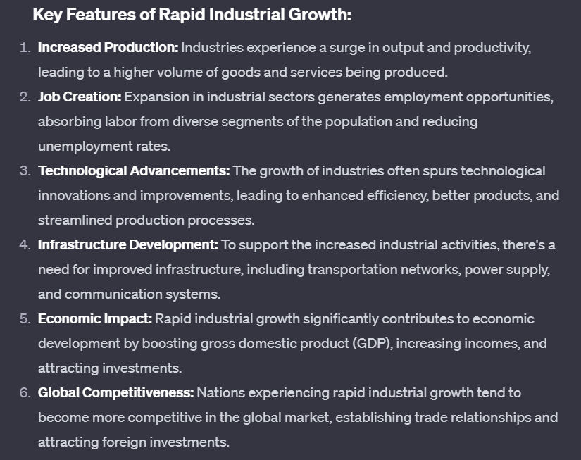

**Consequences : -**

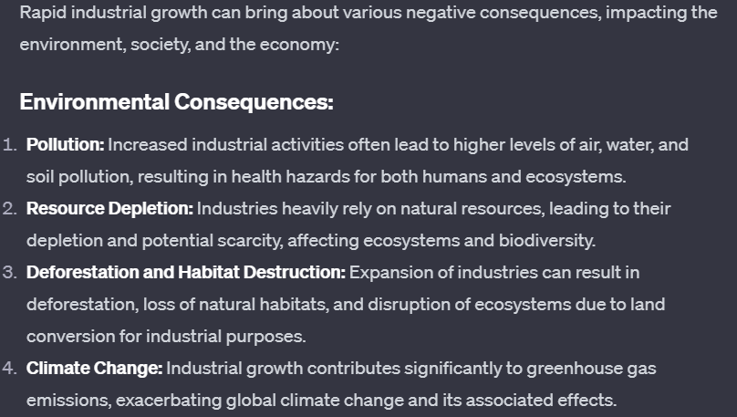

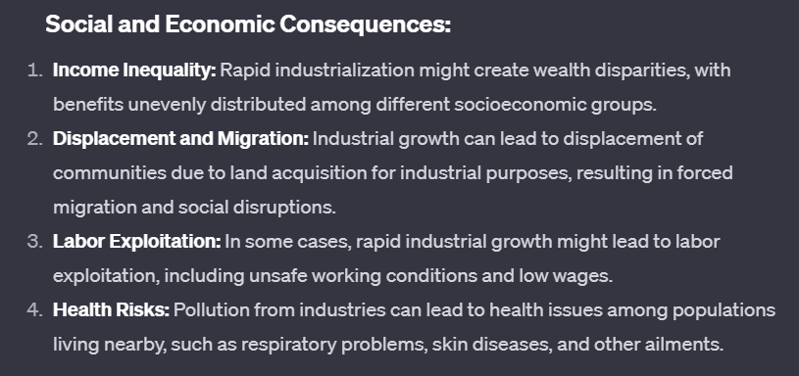

**Renewable Energy Resources**

Renewable resources are natural materials that can be replenished over time through natural processes. They are essentially inexhaustible within a human lifespan or can be renewed relatively quickly. Examples include:

Solar Energy: Generated from the sun's radiation.

Wind Energy: Produced by harnessing the power of the wind.

Hydro-power: Generated from flowing water, typically through dams.

Biomass: Derived from organic materials like wood, crops, or organic waste.

Geothermal Energy: Harvested from the Earth's heat stored beneath the surface.

**Several barriers impede the widespread adoption of renewable resources over traditional non-renewables:**

1) **Infrastructure Challenges**: The infrastructure required for harnessing and distributing renewable energy often needs significant investment and development. Building solar farms, wind turbines, or hydroelectric plants requires specific locations, technology, and grid updates.

2) **Intermittency and Storage**: Many renewable sources like solar and wind energy are intermittent—they depend on weather conditions. Developing efficient and cost-effective energy storage solutions to address fluctuations in supply is a challenge.

3) **Costs and Subsidies**: While renewable technologies have become more affordable, initial setup costs can still be high. Non-renewables, like fossil fuels, have long-standing infrastructure and often benefit from government subsidies, making them economically competitive.

4) **Public Perception and Awareness**: Misinformation or lack of awareness about renewable energy can influence public opinion. Education and outreach efforts are crucial to encourage acceptance and adoption.

5) **Technological Limitations**: Advancements in renewable technology are ongoing. Improvements are needed in efficiency, storage, and scalability to match or surpass the output of non-renewables.

6) **Reliability Concerns**: Some question the reliability of renewable energy sources compared to traditional ones, especially during extreme weather conditions or in remote areas without proper infrastructure.

**Advantages of renewable energy resources: -**

1. **Environmentally Friendly**: They produce little to no greenhouse gas emissions, reducing air and water pollution, and mitigating climate change. This helps preserve ecosystems, biodiversity, and public health.
2. **Inexhaustible**: Renewable resources are essentially limitless and can be continually replenished by natural processes, unlike finite fossil fuels, reducing concerns about depletion.
3. **Diverse Sources**: There's a wide variety of renewable sources—solar, wind, hydro, geothermal, biomass—allowing for flexibility and adaptation to different geographical locations and energy needs.
4. **Job Creation**: The renewable energy sector creates jobs in manufacturing, installation, maintenance, and research, supporting local economies.
5. **Community Benefits**: Renewable projects can often involve local communities, providing opportunities for investment, shared ownership, and revenue generation.
6. **Long-Term Sustainability**: By utilizing resources that naturally replenish over time, renewable energy promotes long-term sustainability and reduces the environmental impact associated with extracting and burning fossil fuels.

**Industrialization**

Industrialization, is the process by which a society or country transforms itself from an agricultural-based economy into one based on the manufacturing of goods and services using advanced machinery and technology.

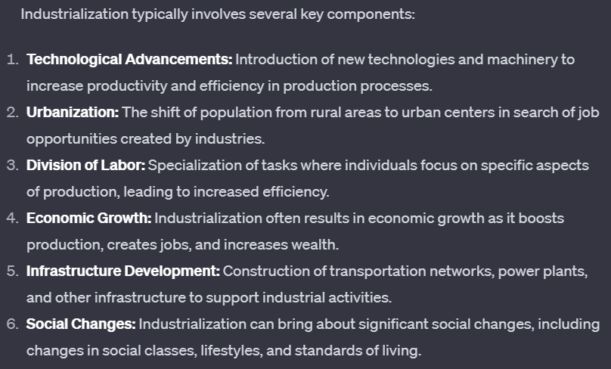

**Disadvantages of Industrialization : -**

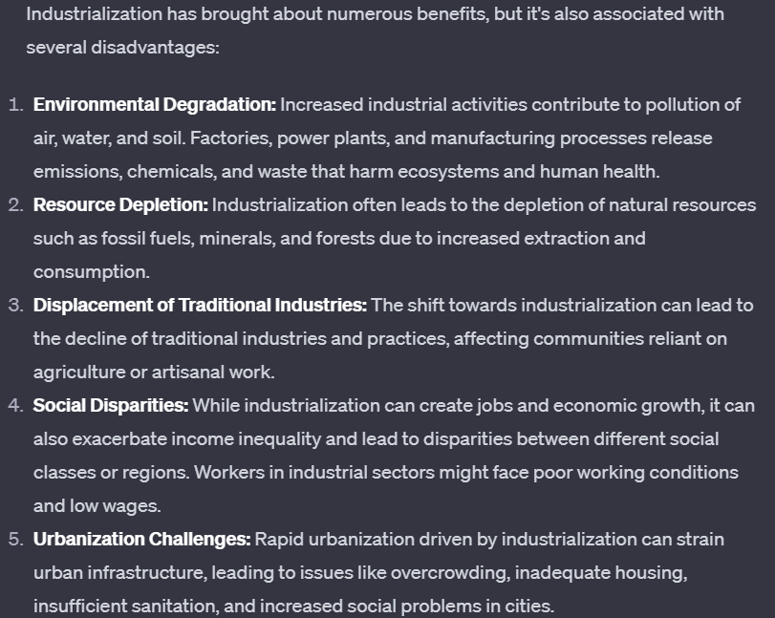

**Man-machine Interaction**

Man-machine interaction, often referred to as human-computer interaction (HCI), is the study and design of how people interact with computers and machines. It focuses on creating interfaces and systems that allow users to communicate and interact effectively with technology.

**Disadvantages of man-machine interaction :-**

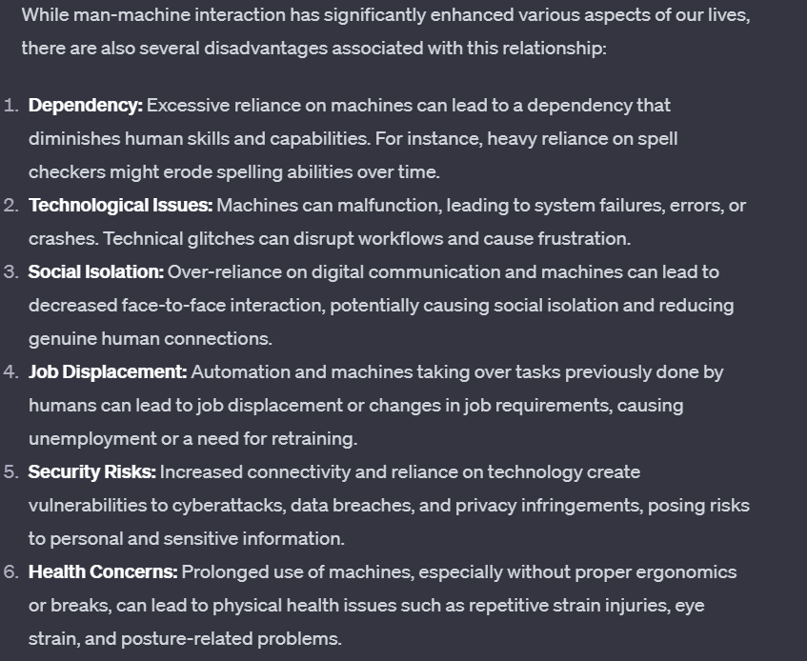

**Technology transfer**

Technology transfer refers to the process of sharing, disseminating, or transferring knowledge, innovations, or technologies from one individual, organization, or country to another for the purpose of further development, commercialization, or implementation. It could involve various forms of collaboration, licensing, joint ventures, or partnerships where expertise, intellectual property, or technological advancements are exchanged or utilized.

**Disadvantages of technology transfer: -**

1) **Costs and Expenses**: The transfer process itself can be expensive, involving legal fees, negotiations, training, and infrastructure investments, which might be prohibitive for some organizations or countries.

2) **Adaptation and Compatibility**: Sometimes, transferred technology might not seamlessly integrate with existing systems or might require significant modifications to be effective, leading to additional costs or delays.

3) **Dependency and Control**: The recipient of transferred technology might become overly reliant on the technology provider for updates, maintenance, or further developments, which could limit autonomy or innovation capacity.

1. **Skills and Knowledge Gap**: Adopting new technology often requires specialized skills and knowledge. If the receiving party lacks the expertise needed to utilize the technology effectively, it can hinder its successful implementation.

Types of technology transfer: -

By **Edwin Mansfield**;

**Horizontal technology transfer** is the movement of technology from one place, organization, or context to another. The goal of horizontal transfer is to spread technology and expand its use, not to commercialize it.

**Vertical technology transfer** is the movement of technology from research to development and production. It includes the stages of invention, innovation, and diffusion, usually by commercialization.

